NAAN MUDHALVAN

NAME:MATHAVAN

COURSE:SALESFORCE

NM ID: **4DD5CA333655433BF0B4AAA52A0D4740**

Task1:

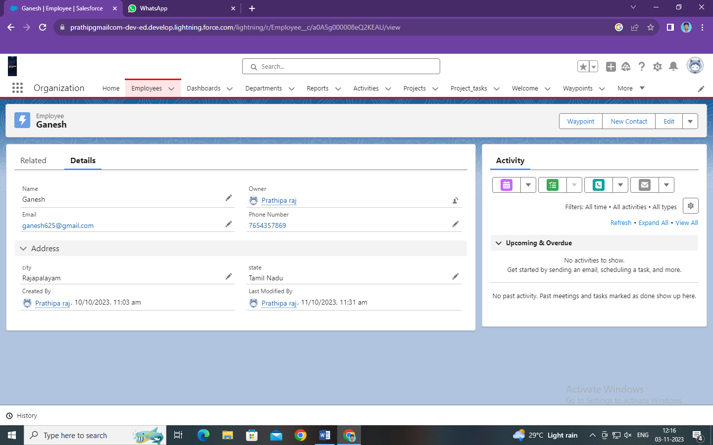

Task 2:

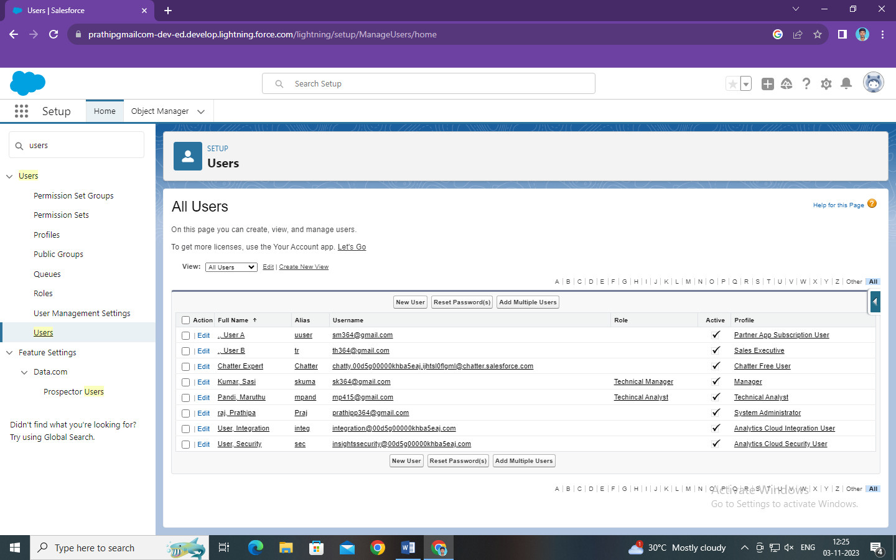

Task 3:

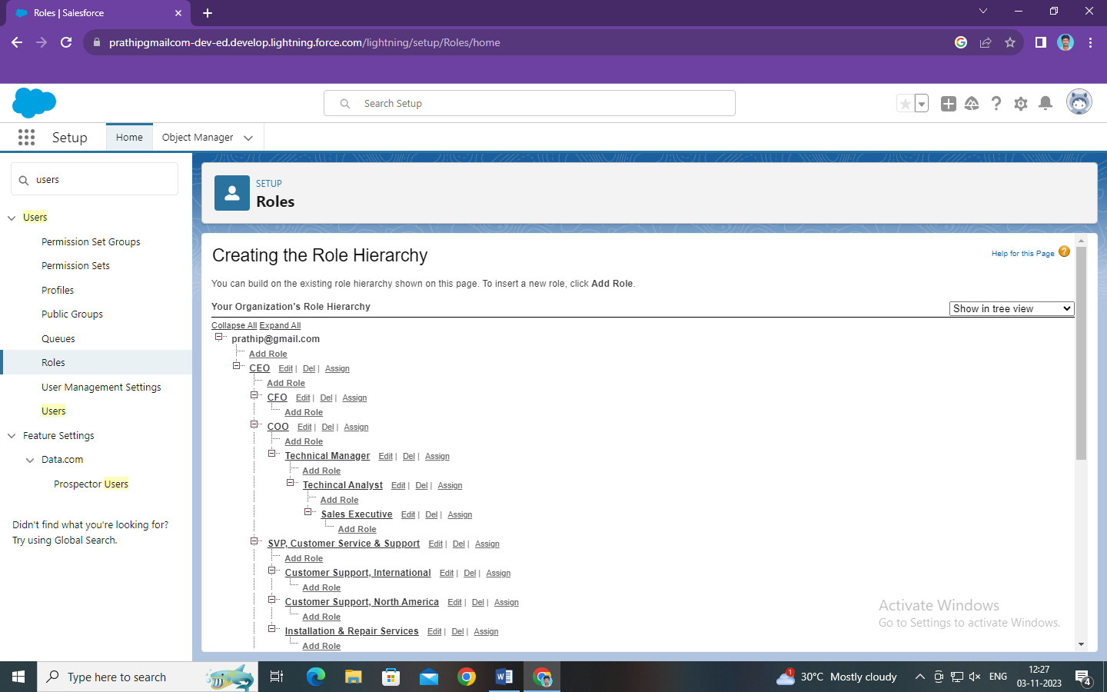

Task 4:

